Bahria University,

Karachi Campus



COURSE: CEN-221

COMPUTER ARCHITECTURE AND ORGANIZATION

TERM: FALL 2020, CLASS: BSE- 3(B)

Submitted By:

_______________________________________________

(Name) (Reg. No.)

Submitted To:

Engr. Ramsha Mashood/Engr. Noor us Sabah

Signed Remarks: Score:_____

INDEX

|  |  |  |  |  |
| --- | --- | --- | --- | --- |
| SNO | DATE | LAB NO | LAB OBJECTIVE | SIGN |
|  |  |  |  |  |
|  |  |  |  |  |
|  |  |  |  |  |
|  |  |  |  |  |
|  |  |  |  |  |
|  |  |  |  |  |
|  |  |  |  |  |
|  |  |  |  |  |
|  |  |  |  |  |
|  |  |  |  |  |
|  |  |  |  |  |
|  |  |  |  |  |
|  |  |  |  |  |
| SNO | DATE | LAB NO | LAB OBJECTIVE | SIGN |
|  |  |  |  |  |
|  |  |  |  |  |
|  |  |  |  |  |
|  |  |  |  |  |
|  |  |  |  |  |
|  |  |  |  |  |
|  |  |  |  |  |
|  |  |  |  |  |
|  |  |  |  |  |
|  |  |  |  |  |
|  |  |  |  |  |
|  |  |  |  |  |
|  |  |  |  |  |
|  |  |  |  |  |

Bahria University,

Karachi Campus



LAB EXPERIMENT NO.

**__**

LIST OF TASKS

|  |  |
| --- | --- |
| TASK NO | OBJECTIVE |
|  |  |
|  |  |
|  |  |
|  |  |
|  |  |
|  |  |
|  |  |
|  |  |
|  |  |
|  |  |
|  |  |
|  |  |
|  |  |
|  |  |
|  |  |

Submitted On:

**Date: ___________**

**Task No. 00:**

**“Write the task here.”**

**Solution:**

You have to paste the screenshot of program written for your task here (jut like below):

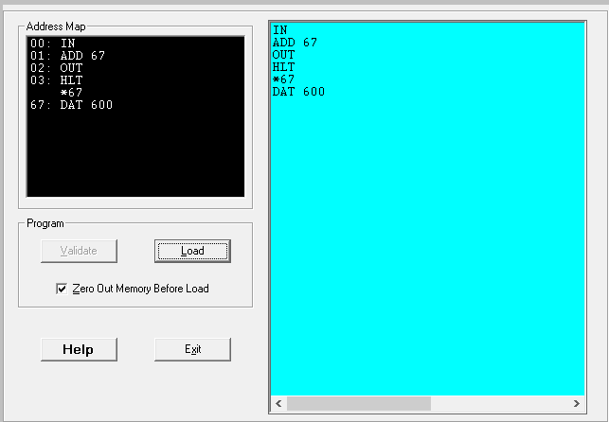

**Output:**

For output, you have to paste 2 screenshot: 1- hardware view, 2- trace view (just like below)

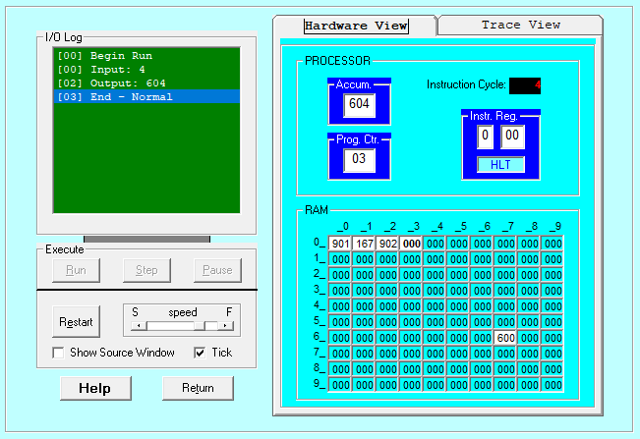

Figure Hardware View

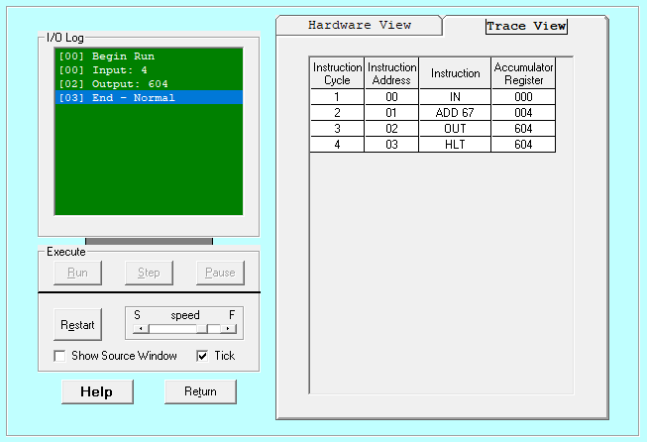

Figure Trace View